**Sample Questions for Social Media Analytics**

1. In the diagram below, which is the node with highest betweenness centrality? Calculate the betweenness score of this node and show your calculations.

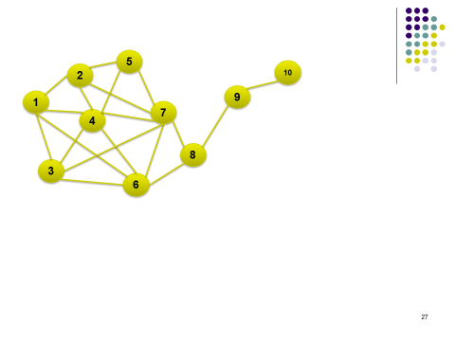

2. A survey was conducted within cohort of 65 students, which asked each student to indicate which 3 students in the class s/he corresponds with the most on Facebook. The Professor then used this data to draw the social graph and calculated the betweenness centrality of each student. The average betweenness centrality came out to be 200.

If the Professor had looked up each student on Facebook and created a social network between these 65 students using the actual friendship or contact list, would the average betweenness centrality be above 200? Justify your response.

1. The following tables show non-directional friendships and attributes of people (perceptions about two brands on a 1-7 scale) in a social network across time.

**Snapshot on January 1, 2020**

**Friendships (“Yes” indicates the presence of friendship)**

|  |  |  |  |  |  |
| --- | --- | --- | --- | --- | --- |
|  | A | B | C | D | E |
| A | - | Yes |  | Yes |  |
| B |  | - | Yes |  |  |
| C |  |  | - |  |  |
| D |  |  |  | - | Yes |
| E |  |  |  |  | - |

**Attributes**

|  |  |  |
| --- | --- | --- |
|  | Perception of brand X | Perception of brand Y |
| A | 3 | 6 |
| B | 7 | 3 |
| C | 5 | 5 |
| D | 7 | 4 |
| E | 5 | 7 |

**Snapshot on March 1, 2020**

|  |  |  |  |  |  |
| --- | --- | --- | --- | --- | --- |
|  | A | B | C | D | E |
| A | - | Yes |  | Yes | Yes |
| B |  | - | Yes | Yes |  |
| C |  |  | - |  | Yes |
| D |  |  |  | - | Yes |
| E |  |  |  |  | - |

|  |  |  |
| --- | --- | --- |
|  | Perception of brand X | Perception of brand Y |
| A | 6 | 4 |
| B | 7 | 3 |
| C | 5 | 4 |
| D | 7 | 4 |
| E | 5 | 6 |

3a. Design a simple test of whether social influence exists in this network and perform (and show) all calculations (can be shown in Excel). Be specific in your answer and state the test precisely.

Test for social influence (description):

Show all calculations on a spreadsheet:

Your conclusion from the analysis:

3b. Design a test and perform the analysis to check the presence of homophily in this specific dataset.

Test of homophily (describe what you will do):

Show all calculations on a spreadsheet:

Your conclusion from the analysis:

1. Find the largest 3-core sub-network from the network below:

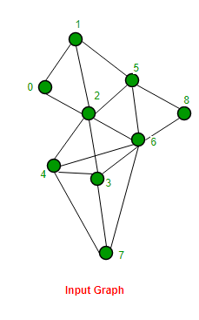

1. Consider k-cores and n-cliques. “If we choose k = n-1 (and n > 2), we are likely to find more cores than cliques from a given network.” Do you agree with this statement? Explain your position.